**SQL – 4**

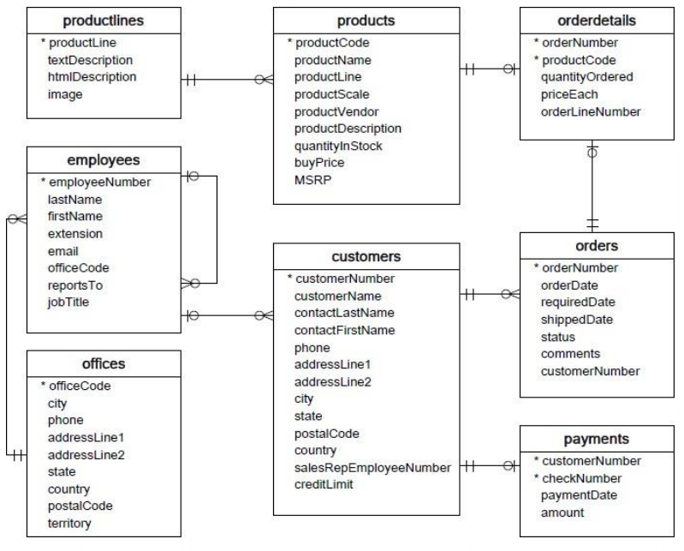

1. Write a SQL query to show average number of orders shipped in a day (use Orders table).

Ans: SELECT COUNT(orderNumber)/COUNT(DISTINCT(shippedDate)) AS avg_ord_ship_1_day FROM orders;

2. Write a SQL query to show average number of orders placed in a day.

Ans: - SELECT COUNT(orderNumber)/COUNT(DISTINCT(orderDate)) AS avg_num_ord_1_day FROM orders;

3. Write a SQL query to show the product name with minimum MSRP (use Productstable).ASSIGNMENT

Ans: SELECT productName,MSRP FROM products

WHERE MSRP =

(SELECT MIN(MSRP) FROM products);

4. Write a SQL query to show the product name with maximum value ofstockQuantity.

Ans: SELECT productName,quantityInStock from products

WHERE quantityInStock =

(SELECT MAX(quantityInStock) FROM products);

6. Write a SQL query to show the highest paying customer Name.

Ans: - SELECT customerName FROM customers

WHERE customerNumber = (SELECT customerNumber FROM payments

WHERE amount=(SELECT max(amount) FROM payments));

7. Write a SQL query to show cutomerNumber, customerName of all the customers who are from Melbourne city.

Ans: SELECT customerName,customerNumber FROM customers

WHERE city = 'Melbourne';

8. Write a SQL query to show name of all the customers whose name start with “N”.

Ans: SELECT *

FROM customers

WHERE customerName LIKE 'N%';

9. Write a SQL query to show name of all the customers whose phone start with ‘7’ and are from city ‘LasVegas’.

Ans: - SELECT customerName,phone from customers

WHERE phone LIKE '7%' AND city='Las Vegas';

10. Write a SQL query to show name of all the customers whose creditLimit < 1000 and city is either “Las Vegas” or ”Nantes” or “Stavern”.

Ans: SELECT customerName,creditLimit from customers

WHERE creditLimit>1000

AND

city='Stavern' or city='Las Vegas' or city='Nantes';

11. Write a SQL query to show all the orderNumber in which quantity ordered <10.

Ans: SELECT orderNumber,quantityOrdered from orderdetails

WHERE quantityOrdered<10;

12. Write a SQL query to show all the orderNumber whose customer Name start with letter ‘N’.

Ans: SELECT orderNumber

FROM orders

LEFT JOIN customers

ON customers.customerNumber = orders.customerNumber

WHERE customers.customerName LIKE 'N%'

13. Write a SQL query to show all the customerName whose orders are “Disputed” in status.

Ans: SELECT customerName

FROM customers

LEFT JOIN orders

ON customers.customerNumber = orders.customerNumber

WHERE orders.status = 'disputed';

14. Write a SQL query to show the customerName who made payment through cheque with checkNumber startingwith H and made payment on “2004-10-19”.

Ans: SELECT customerName,checkNumber,paymentDate FROM customers

RIGHT JOIN payments

ON customers.customerNumber = payments.customerNumber

WHERE payments.checkNumber LIKE 'H%'

AND payments.paymentDate = '2004-10-19';

15. Write a SQL query to show all the checkNumber whose amount > 1000.

Ans: - SELECT checkNumber

FROM payments

WHERE amount>1000;